We wanted to let you know that Health Advocate is ready to help you and your employees in response to the impending impact of Hurricane Irma.
Here’s how we have prepared:
• | Reviewed our crisis plan and mobilized our back-up team
• | Created protocols for this team to receive updates and action plans
• | Updated our website with resources for those impacted
• | Added 50 additional counselors
• | Prepared our secondary call centers who are ready to assist 24/7
In addition, please forward the below email to your employees to tell them about how we can help those affected by Hurricane Irma.
If you would like a digital flyer with this information, please email info@HealthAdvocate.com or call 866.799.2655.
Please forward to your employees.
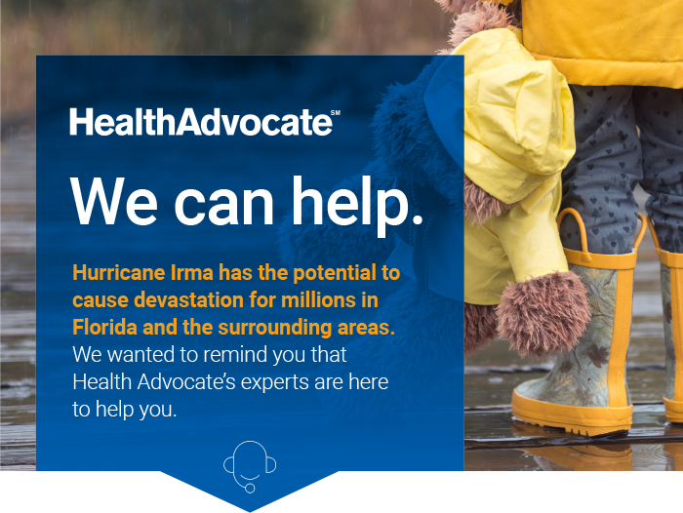
To get started, just call: 866.799.2728

Healthcare Help

Find providers that will be able to provide temporary assistance
Transfer medical records and prescriptions
Help get a short supply of medications if prescriptions have been lost
Assist with elderly parents

Emotional Support

Talk to a licensed clinician to develop strategies to help you and your family adjust
Help with anxiety, stress, how to talk with your kids
Tips to stay positive and productive

Information and Resources

Find government relief organizations to assist with finding temporary and permanent housing
Access local, state and federal agencies

Click here for Hurricane Irma resources.
Visit the Health Advocate Member Website for additional resources.
www.healthadvocate.com/members

Click here for our award-winning healthcare blog

We're not an insurance company. West's Health Advocate Solutions is not a direct healthcare provider, and is not affiliated with any insurance company or third party provider.

